AN EXAMINATION OF CONSCIENCE



Do I think about God every day?

Do I speak to God every day through prayer?

Do I worship God at Mass every week?



Do I live how Jesus shows how to live?

Am I kind others?

Do I share with others?

Do I show respect to my parents, teachers and friends?



Am I sometimes greedy?

Do I appreciate what God has given me?

Do I think of ways to help those who have no food?

Do I take things that do not belong to me?

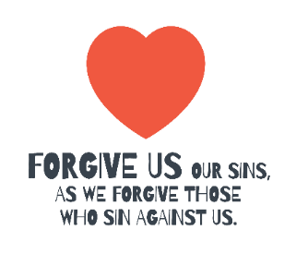

Do I say I am sorry when I have been wrong?

Do I forgive when someone does something bad to me?

Do I help solve problems between my friends or do I cause more trouble?

Do I say bad things about people who have hurt me?

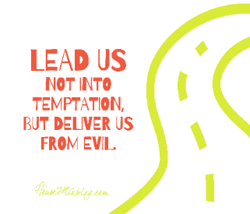

Do I play fairly in sports and games?

Do I cheat in school?

Do I tell the truth?

Do I let others tempt me to do things I know I should not do?